# Lab 3 – RSA Encryption and Decryption Lab

## Task 1.1

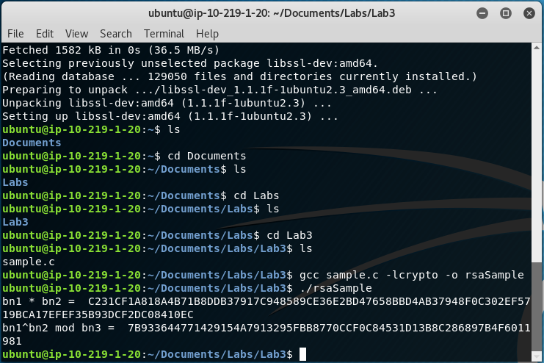

## Task 1.2

* Changing the last 9 digits of the string passed to bn2 to 123456789 (rsaSample1)

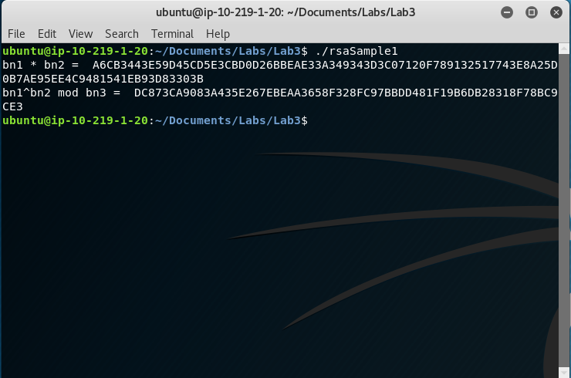

* Changing the last two parameters of the bn3 function to 1 and 2 (rsaSample2)

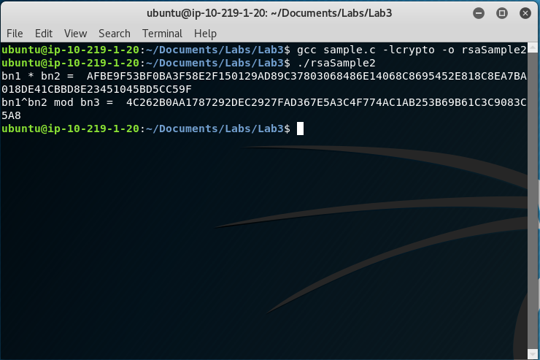

* Changing the three null values for bn1 to BN_new(), BN_new(), and BN_GENCB_new() respectively (rsaSample3)
  + This was done with trial and error of reading the compiler error output to see what object types it was looking for and creating those new objects with the library functions respectively.

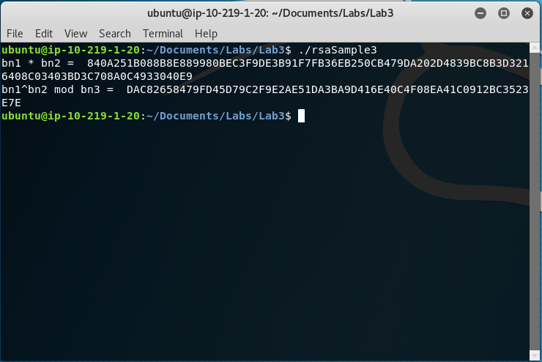

## Task 2.1

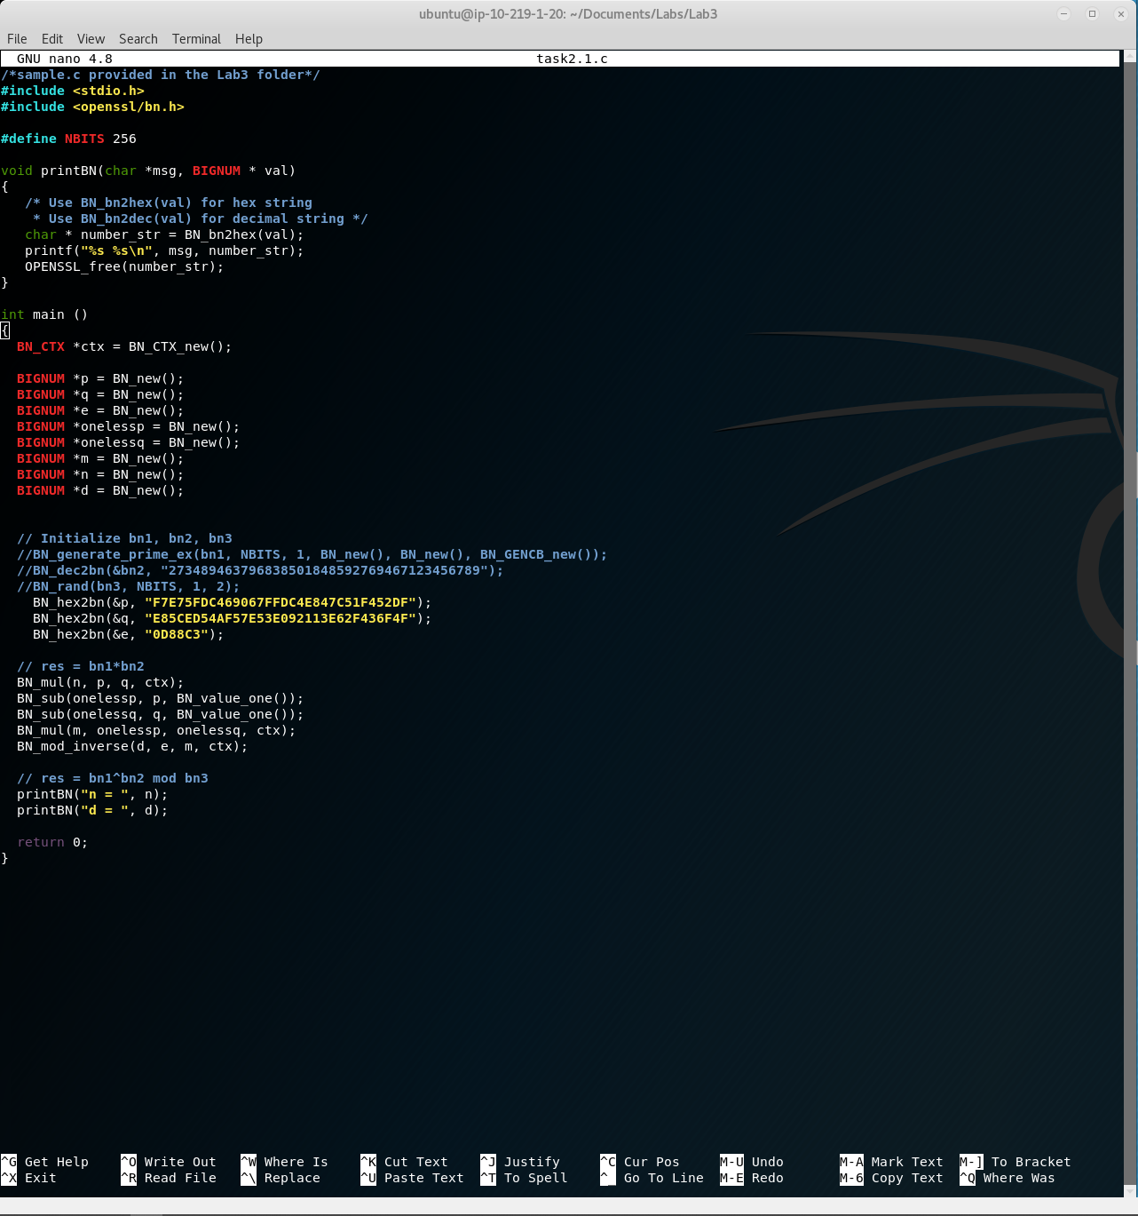

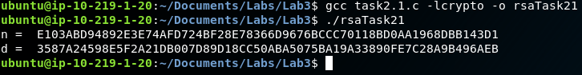

## Task 2.2

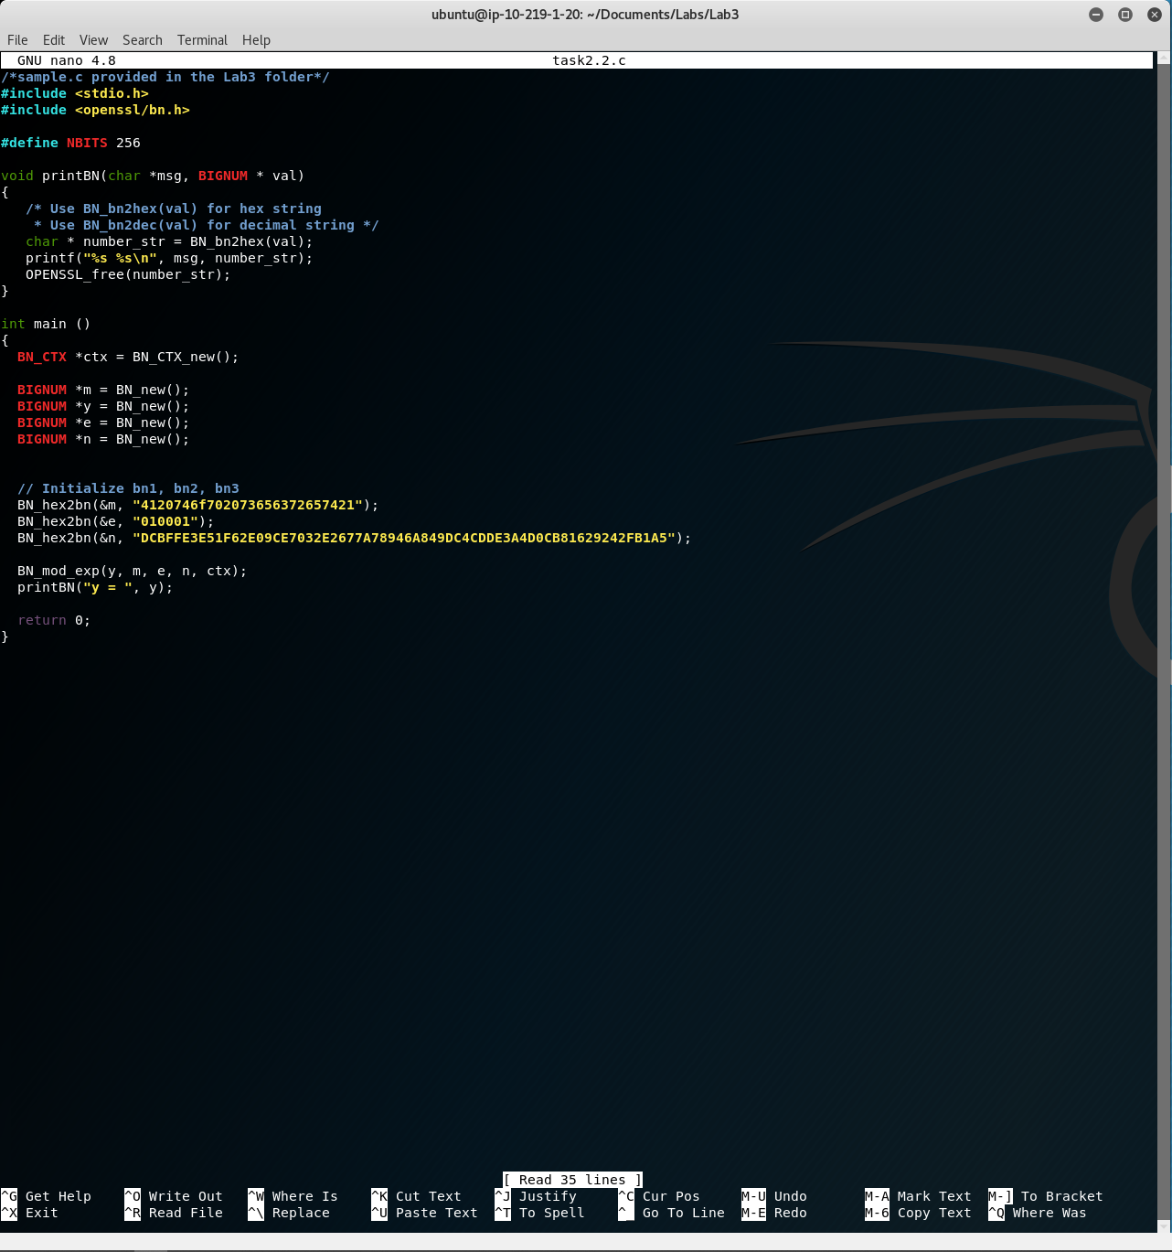

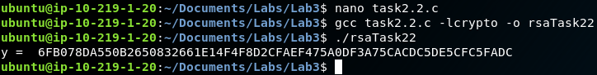

## Task 2.3

